**STEPS TO EXTRACT DATA FROM OCTOPARSE:-**

**1.FIRST OPEN IT AND IN ADVANCED MODE SELECT START.**

**2.THEN GIVE YOUE DESIRED TASK NAME AND SELECT NEXT.**

**3.THEN COPY THE LINK OF YOUR WEBSITE THEN PRESS ON EARTH IAMGE BUTTON.**



1. **THEN IF YOUR WEBSITE IS LIKE PRODUCES MORE RESULT BY SCROLLING THROUGH LAST PAGE THEN GO TO ADAVANCE OPTION AT RIGHT CORNER THEN CHECK ON ‘SCROLL DOWN THE PAGE’.**
2. **GIVE YOUR DESIRED NO. OF SCROLLS ,NO. OF SECONDS AND THEN CLICK ON SAVE BUTTON.**
3. **THEN SELECT ANY BOX.**
4. 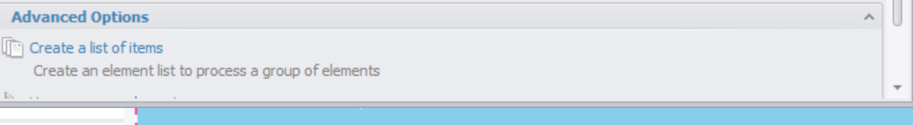

**THEN CLICK ON THIS.**

1. **THEN ON THIS.**
2. 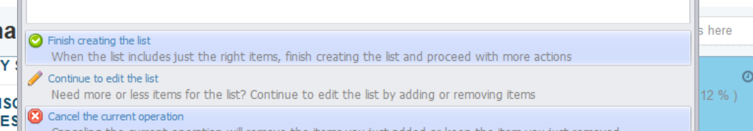

**THEN ON ‘CONTINUE TO EDIT THE LIST’**

1. **THEN AGAIN SELECT ANY OTHER BOX**
2. **THEN CLICK ON THIS ‘FINISH’**



1. 

**THEN CLICK ON ‘LOOP’.**

1. **THENCLIXK ON TEXT AND CLICK ON THIS EXTRACT TEXT.**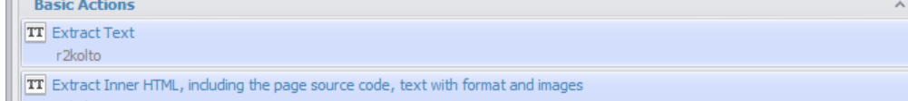
2. **THEN FOLLOW THIS STEP FOR EXTRACTING TEXT AND THEN FINALLY CLICK ON NEXT AND THEN ON NEXT**
3. **THEN FINALLY ON THIS.**

